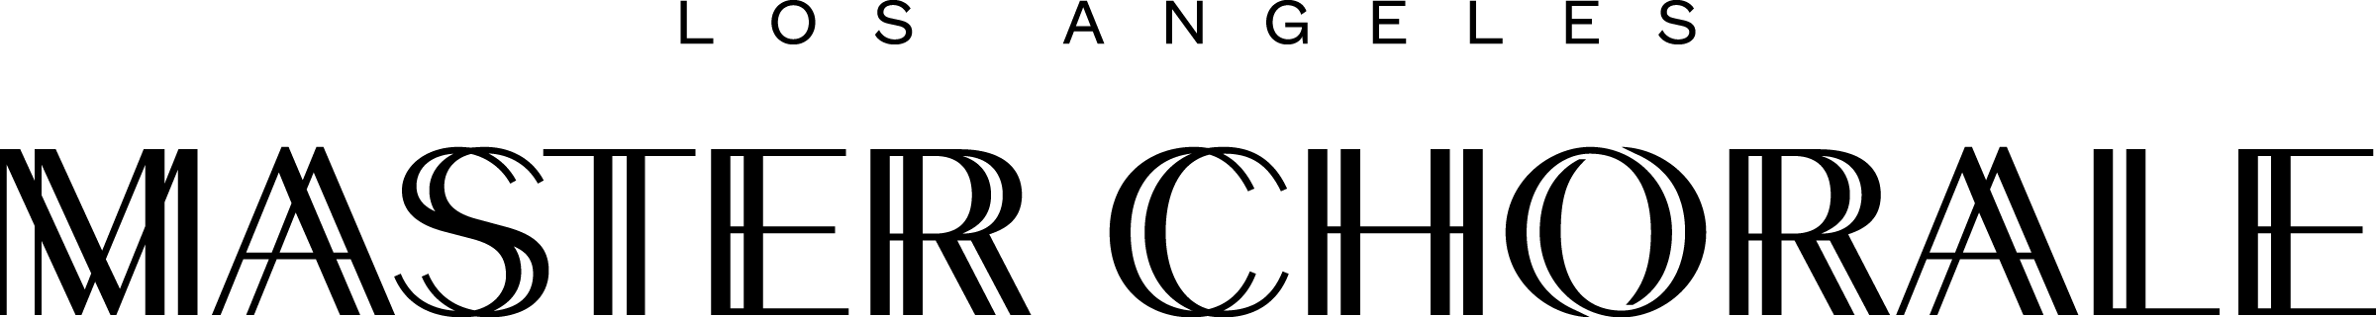

LOS ANGELES MASTER CHORALE TO RECEIVE $50,000 GRANT FROM THE NATIONAL ENDOWMENT FOR THE ARTS

LOS ANGELES ( February 8, 2021 ) – The Los Angeles Master Chorale, led by Grant Gershon, Kiki & David Gindler Artistic Director, has been approved for a $50,000 Grants for Arts Projects award to support the continued production of virtual content, including the upcoming premiere of composer Meredith Monk’s “Earth Seen from Above” from her opera Atlas, and the world premiere of composer Derrick Spiva, Jr’s “Ready, Bright,” a Los Angeles Master Chorale commission.

Both videos will be presented at the Master Chorale’s upcoming virtual gala on May 16, 2021, along with Reena Esmail’s “TaReKiTa,” as part of a triptych titled Shine Bright. The entire program will engage all 100 Master Chorale singers.

The “TaReKiTa” video was released in November 2020 and is available here; the videos for “Earth Seen from Above” and “Ready, Bright” will also be released publicly at a future date to be determined.

“The National Endowment for the Arts is proud to support this project from the Master Chorale,” said Arts Endowment Acting Chairman Ann Eilers. “The Master Chorale is among the arts organizations across the country that have demonstrated creativity, excellence, and resilience during this very challenging year.”

“We are incredibly grateful to the NEA for their support, especially during the pandemic period,” said Jean Davidson, President and CEO, Los Angeles Master Chorale. “We will continue to share the joy of choral music virtually, and look forward to the day when we can return to Walt Disney Concert Hall.”

For more information on projects included in the Arts Endowment grant announcement, visit
arts.gov.

ABOUT THE LOS ANGELES MASTER CHORALE

LOS ANGELES MASTER CHORALE MEDIA CONTACT:
Lisa Bellamore, Crescent Communications
lbellamore@gmail.com, 323-500-3071

###

